Egerton Team
The Egerton team is comprised of the following
- Isaac Kosgei- 4th Bsc Agribusiness Management.
- Bethuel K. Kiay-4th year Bsc. Computer Science.
- Edward Yego-3rd year Bsc. Economics and statistics.
The above team has successfully done the following projects:-
- Visited a number of schools in rift valley and managed to install Kiwix.
- Collected data/ feedback from the schools we have visited including recommendations.
- Represented Wikimedia Kenya during the Egerton University open Day held on 17th Feb 2011 at Egerton’s sports Ground where the higher Education minister was the Guest of honour.
- Prepared a catching PowerPoint presentation about Wikipedia for schools project.
- Sensitized the staff and students at Egerton about Wikimedia foundation and our project.
- Planning to represent Wikimedia for schools in a national exhibition organized by the commission for higher Education- ( will be Held in Kakamega on 17th-19th march 2011)
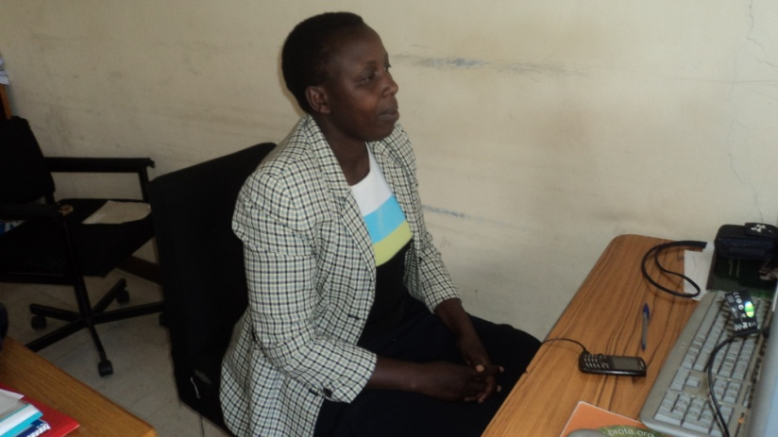
Dr. Birech reading the Wikipedia for schools in her office at Utafiti Egerton uni

Schools Covered in Our Region
- Kapsabet Boys’ High school.
- Kapsabet Girls’ High School.
- Nakuru high school.
- Egerton Secondary school.
- Kaptel high school.
- Njoro boys
The reception in the above schools was very wonderful. Only Kaptel boys did not take coz they said the headmaster was not around, as for Egerton secondary we will be installing it on Mon 21st.
We still plan to visit a few other schools at random before we compile our report. The major points noted positively by the teachers of the schools we visited are:-
- They appreciate the fact that it is donated free of charge especially the fact that they get a free DVD copy of the software.
- It does not worry the teacher that his/her students can access irrelevant material e.g. adult content.
- It is easy to install and easy to use.
- It is a very good reference copy for the teachers.
- It is good for general knowledge.
The disadvantages are :-
- It has no Kiswahili which is part of the examinable subjects they are therefore recommending that it be included.
- It is note updated with the current events happening in the world the chronology of events is updated only to 2004. ( click 2005 and you won’t find)
- The English Grammar is very shallow as compared to the Kenyan syllabus.
- The Sciences are complex for the students especially. It covers a lot of things that aren’t in the syllabus and students may end up wasting time reading things that won’t be examined they expect to find topic like preparation of chemical elements in chemistry- including diagrams of the same.(Others Noted this as a positive in that for those who are curious with a topic thy can follow it up)
- The African History has not been covered well esp. as per the syllabus.

Subjects that met the threshold
- Mathematics.
- Biology.
- Geography.
- General knowledge.
Recommendations
The Heads of the schools we have gone so far put forward the following recommendations
- Revised the content as per the Kenyan syllabus coz the current one seems to have been tailor made for a syllabus in another country.
- Include Kiswahili.
- Include Examples and answers especially in the area of mathematics and sciences.
- Make a follow up of schools
- Organize to give motivational talks to students on topics like e-learning.
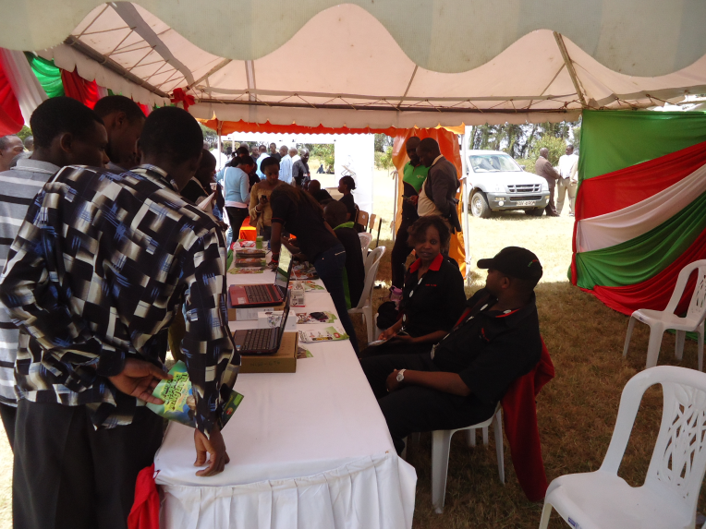
Students looking at Wikipedia for schools displayed on a laptop
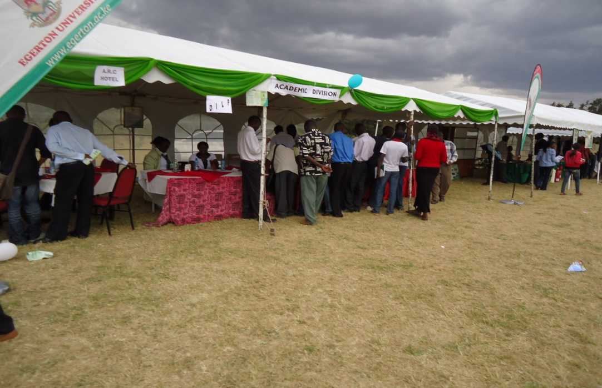
ACADEMEIC STAND DURING OPEN DAY

