WIKI LOVES EARTH 2017 – INDIA

Wiki Loves Earth (WLE) is a public photo competition on Wikimedia Commons for use on Wikipedia and other project websites of the Wikimedia Foundation. The Wikimedia India Chapter is running this contest. The aim of this project is to improve the quality of pictures of different local natural heritage and scenic landscape of the Indian sub-continental region and to celebrate India’s ecological diversity and beauty.

The contest is aimed to educate people about and promote donating images to the Commons on a national scale.The aim of the event is to highlight the conservation areas of the participating countries with the goal to encourage people to capture pictures of these sights, and to put them under a free licence which can then be re-used not only in Wikipedia but everywhere by everyone. India has a vibrant photography community which would truly be an asset to this project.

Preface

Wiki Loves Earth (WLE) is an annual international photographic competition, organized worldwide by the Wikimedia Community Members with the help of local Wikimedia affiliates across the globe. Participants take pictures of local natural heritage and scenic landscape in their countries, and upload them to and upload them on Wikimedia Commons.

The first Wiki Loves Earth competition was held in 2013 in the Ukraine as pilot project. In the next years the competition become international and spread to other countries. In 2014, the competition was extended beyond Europe, with a total of 16 participating countries. The 2015 edition of Wiki Loves Earth has seen more than 8,500 contestants participating from 26 countries, with over 100,000 photo submissions. The 2016 edition of Wiki Loves Earth has seen more than 8,500 contestants participating from 24countries, with over 114,000 photo (India 31,300+) submissions.

PREVIOUS WINNERS - 2016

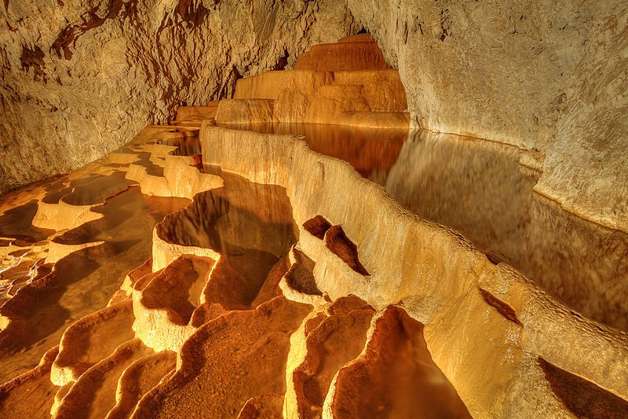

Description: Stopića cave is a limestone cave near Sirogojno, on the slopes of Mount Zlatibor in the Dinaric Alps, in western Serbia.

PREVIOUS WINNERS - 2015

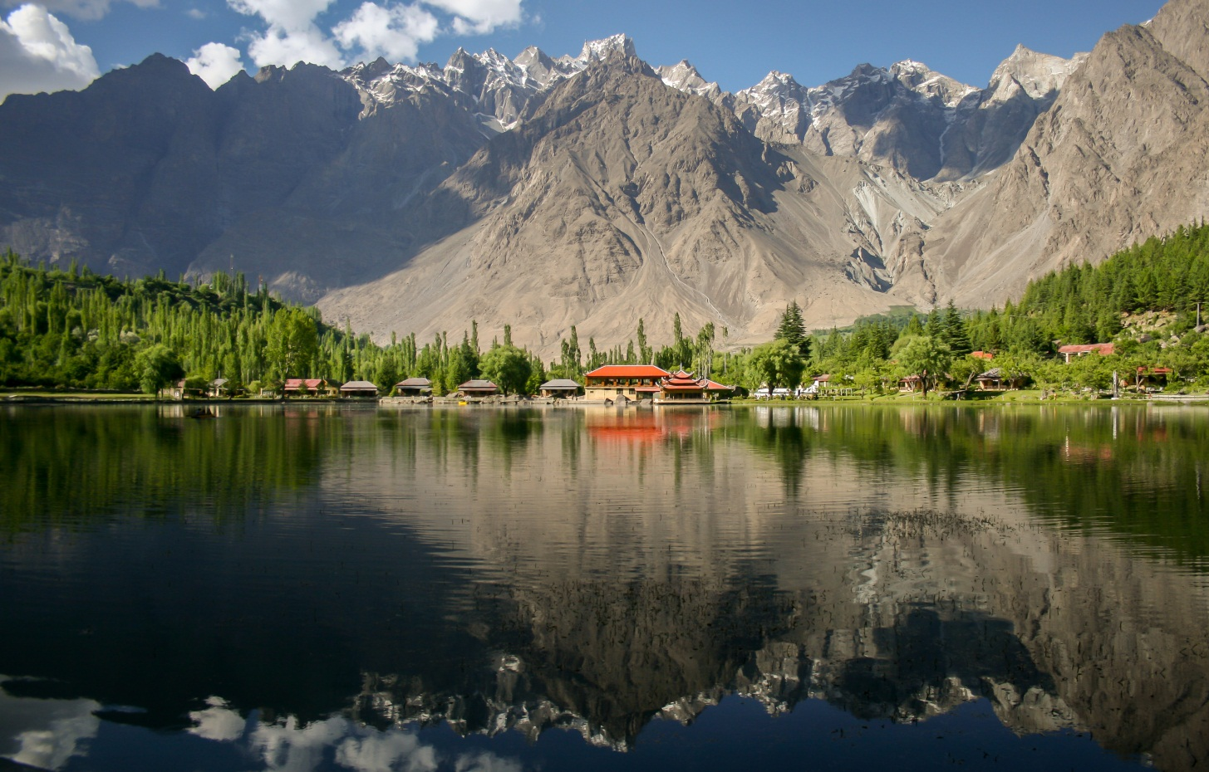

Description: The picture is shot at Shangrila resorts, Skardu. This lake is also known as Lower Kachura lake. Central Karakoram National Park, Gilgit–Baltistan.

PREVIOUS WINNERS–2014

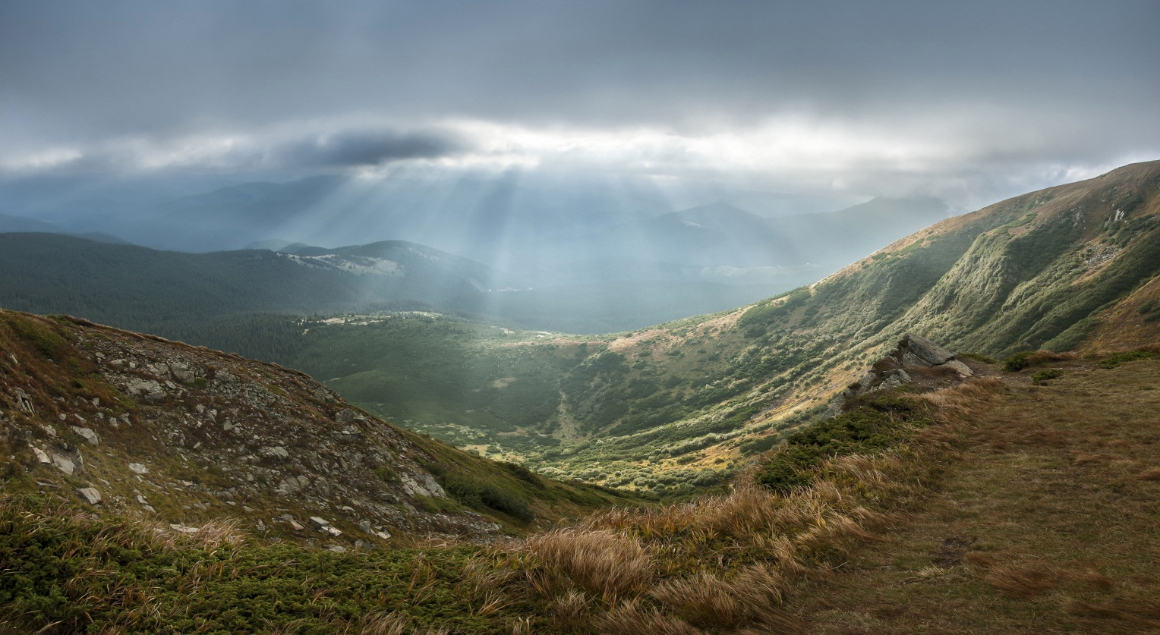

Description: View of Carpathian National Park from Hoverla. Carpathian National Park, Ivano-Frankivsk Oblast, Ukraine.

PREVIOUS WINNERS – 2013

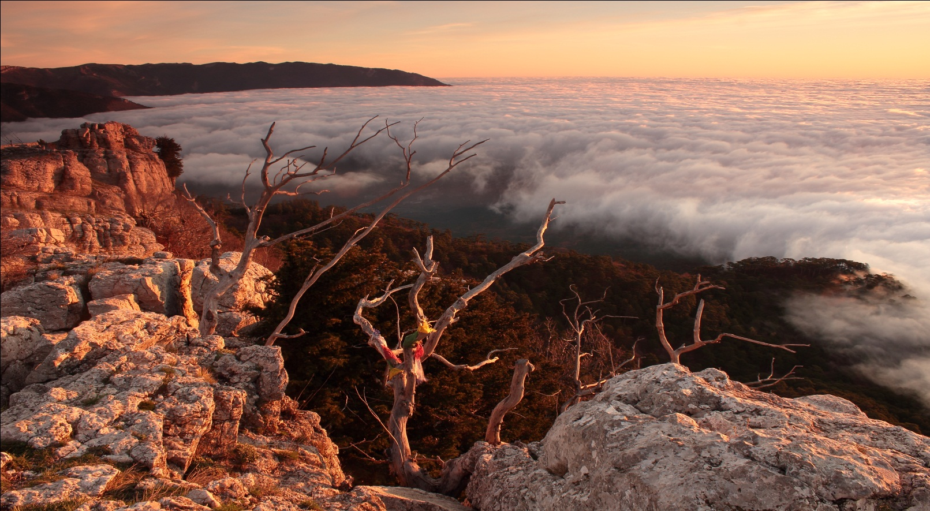

Description : Dawn in the Ai-Petri Yaila nature reserve, Ukarine.

Privacy Policy

Rules

To take part in Wiki Loves Earth contest, a submission should:

- Beself taken.
All entries must be original photographs uploaded by their authors. Photos uploaded by anyone else than the author (even with permission) are not accepted.

- Be self uploaded during the contest period (June 2017);
You are also welcome to submit photos you may have taken in the past. What matters is that photos must be uploaded during the contest period (June 2017)

- Be under a free license;

- Contain an identified natural park protected area etc.;
Lists of eligible sites have been listed on the subsequent page . Photos of representative species (animals, plants ,etc.) taken in an eligible site also qualify if they are properly identified.

- Be nominated through a national contest;

- Have at least 2Megapixel (Mpx)
- A participant should have an activated e-mail address via Preferences of his/her account.

Eligible Sites

All protected or listed areas along with its natural Flora or Fauna in India are within the scope of this competition.Protected areas may be defined as locations which receive protection because of their recognized natural, ecological and/or cultural values. The term "protected area" also includes Marine Protected Areas, the boundaries of which will include some area of the ocean, and Transboundary Protected Areas such as Transboundary rivers Brahmaputra river that overlap multiple countries (India, Bangladesh, China).

Some of the identified areas in India have been listed

- Tiger Reserves in India
- Biosphere reserves in India
- Potential Biosphere Reserve sites in India
- Reserve Forests of India
- Waterfalls of India
- National Parks of India
- Botanical gardens in India
- Aquaria in India
- Zoos in India
- Rivers of India
- Elephant Reserves in India
- Mountains in India
- Endangered Animals in India
- Birds of India
- Wildlife of India

Please visit: https://commons.wikimedia.org/wiki/Commons:Wiki_Loves_Earth_2017_in_India

JURY

