Col. Hessing’s Tomb:
The Red Taj Mahal or John William Hessing’s Tomb was built by his wife in the memory of her husband. If Taj Mahal is known for the love of a husband for his wife, then on the other hand, the Red Taj Mahal is known for the love of a wife for her husband. It was built by Ann Hessing, wife of Duch Soldier after his death in 1803. Colonel John William Hessing was in military services working with various rulers in India. He was hailed from Utrecht, Holland. He came to Shrilanka for military services of Dutch E.I. Company in 1752. He was part of troops capturing Candia. He returned Holland after five years of war. John William Hessing came to India in 1763 and served under the Nizam of Deccan and the Scindias. He fought many battles for the kings of Scindia attaining promotions for the same. In 1787 he also became famous for his bravery during the battle of Bhondegaon near Agra. In 1793 he served under Dowlat Rao Scindia and became a Colonel. Until his death in 1803, he held command of Agra Fort in Agra.
The “Red Taj Mahal” or the European Cemetery is situated on the eastern extension of the M.G. Road (Mahatma Gandhi Road) of Agra in between the Civil Court and Bhagwan Talkies.
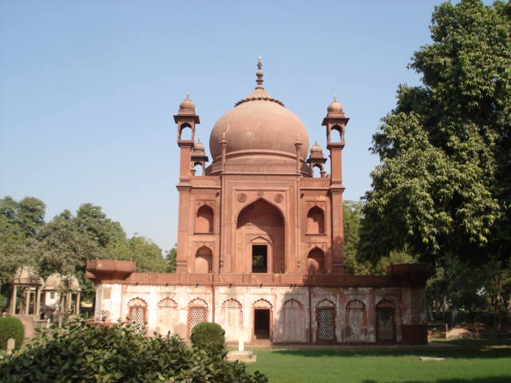Fig. 33. The Red Taj Mahal or John William Hessing’s Tomb

Guru ka Tal, Gurdwara

Guru-ka-tal Gurdwara is a historical Sikh pilgrimage place dedicated to the memory of ninth Guru Sri_Guru_Tegh_Bahudar_Ji. The Gurudwara was built over the place where the Guru Tegh Bahadur laid down his arms to offer arrest to Aurangazeb, the Mughal Emperor. The Guru was kept here under custody for nine days. Several devotees gather every year to pay homage to the great Sikh guru in this Gurudwara.
This historic place dates back to the 17th century. Earlier it was a Tal (reservoir) in the area near Sikandra, Agra. It was built in 1610 AD to collect and conserve rainwater in Agra during Jehangir reign. The water of the reservoir was used for irrigation purposes during the dry season. The reservoir was ornamented with stone carvings.. The Gurudwara called Guru Ka Taal was built in 1970s due to the contributions and arduous efforts of Sant Sadhu Singh Mauni.
There were twelve towers in the Tal, but only eight towers have survived the test of time and have now been retrieved. This red stone structure bears similarity to many other magnificent structures of the Mughals like the Agra Fort, Fatehpur Sikri etc.

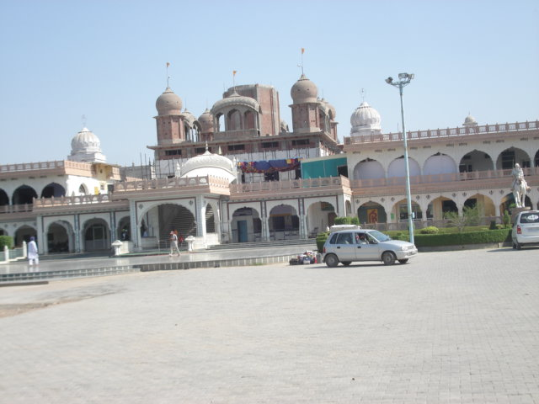
Fig. 34. Gurudwara Guru-ka-tal, Agra

