Sharing Energy Numbers:
An Introduction to MegaJoule.org

Draft, June 10, 2012

Max Henrion and Evan Sherwin

henrion@Lumina.com

evan@Lumina.com

Summary
A large and growing community of energy analysts at universities, industry, government, and NGOs are involved in quantitative projections relating to energy. They are interested in evaluating new energy technologies, business plans, R&D programs, and public policies in terms of economic and environmental effects. In addition, a growing number of students and citizens are becoming more engaged with questions that relate to energy. More generally, they seek to illuminate possible paths to a more sustainable World. To perform these analyses, they need estimates of a wide variety of quantities — not just current numbers, but credible projections into the future, preferably with some assessment of their uncertainty. It can be a lot of work to find such estimates and determine which are credible.
We describe an initial release of Megajoule.org, an online resource for people to share and compare such numbers. Like Wikipedia, anyone can view and contribute to Megajoule.org. Unlike Wikipedia, contributors are publically identified to give credit where due. Contributors may not edit or delete contributions by others, but are encouraged to rate and review each other’s estimates, and add their own estimates. We provide a description of the tool in its current state. To illustrate the distinguishing advantages of our approach, we briefly describe some existing online resources for energy information. You are also invited to explore the beta version for yourself at www.MegaJoule.org.

Acknowledgments
We gratefully acknowledge support from Carnegie Mellon University, Center for Climate Decision Making (cdmc.epp.cmu.edu) with funds from the National Science Foundation, and from the Pacific Northwest National Laboratory, with funds from the Vehicle Technology Program of the US Department of Energy (www.eere.energy.gov/vehiclesandfuels). Lumina Decision Systems has also supported this work with internal R&D funds.

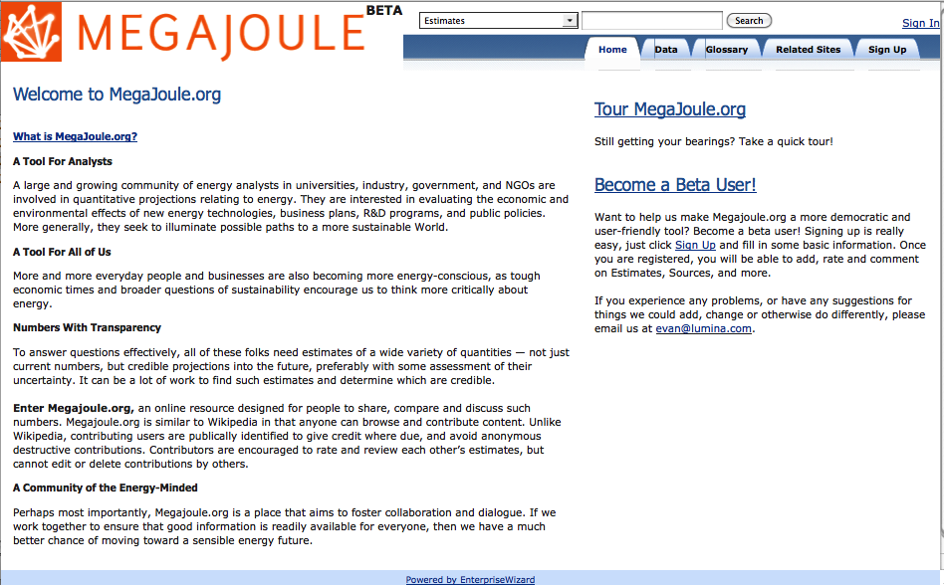
Figure 1: The Homepage of MegaJoule.org

Table of Contents

Summary 1
Acknowledgments 2
Table of Contents 1
Introduction 2
A Wiki, but Not Like Wikipedia 2
How MegaJoule.org Differs From Existing Resources 3
MegaJoule.org at a Glance 5
Focus of Existing Content 8
Graphing Engine 9
Current Design Elements 9
Software 11
Join the MegaJoule Community 11
Conclusion 12

Introduction
A large and growing community of energy analysts in universities, government, industry, and NGOs are involved in making quantitative projections about use of energy. They are interested in evaluating new energy technologies, business plans, R&D programs, and public policies in terms of economic and environmental effects. More generally, they seek to illuminate possible paths to a more sustainable World.
To perform these analyses, this community needs credible estimates of a wide variety of numbers. For example, to assess the economic and environmental impacts of advanced biofuels, we need estimates of the cost and availability of cellulosic biomass, the cost and efficiency of ethanol production, and projections of the market penetration of ethanol in the form of E10, E85, and perhaps E15 as an automotive fuel. Or to estimate the effect of plug-in hybrid vehicles in the US, we need estimates of the lifecycle cost of batteries, the fraction of time the vehicles are driven using battery versus chemical fuel, and again the market adoption of these new kinds of vehicles — to mention just a few. We need estimates not just of current numbers, but projections of the future performance and cost of technologies as they are improved through research and development, and economies of scale in manufacturing. Such forecasts are difficult, and often controversial. So, it is also desirable to have explicit assessments of the uncertainty around the numbers.
For energy analysts who perform these kinds of studies, it often takes a lot of effort to find and select the most credible estimates. Many are controversial — for example, in recent years there have been widely differing estimates of the net energy and greenhouse gas emissions involved in producing ethanol from corn. Some argue that it provides a major reduction, and others that the energy used for fertilizer, agriculture and ethanol production is almost as much as the energy embodied in the ethanol.
To address these needs, we are developing MegaJoule.org, an online resource for sharing these kinds of estimates. It provides a place for energy analysts, policymakers and anyone else interested to find the estimates they need, share these estimates with others, and provide comments, critiques, and comparisons of alternative estimates.
This paper offers a description of the current version of MegaJoule.org, along with ideas for features we hope to add in the future. As MegaJoule.org becomes more widely used, we anticipate that it will evolve as users suggest areas to improve and extend over time.

A Wiki, but Not Like Wikipedia
Wikipedia is undoubtedly the best-known wiki, or public online resource composed of community-generated content. Megajoule.org is a kind of wiki: Anyone can access it and use the information it contains, and anyone can contribute content. With that said, MegaJoule.org differs from Wikipedia in several major respects:
- Focus on numbers: Instead of focusing on text and graphics, MegaJoule.org is focused on numerical Estimates. These Estimates are quantitative measurements related to the current or projected future performance of energy and environmental technologies, such as efficiency, cost, or greenhouse gas emissions.
- Structured Information: Estimates in MegaJoule.org are stored in a structured database to ensure that they are complete, comparable, and searchable. This structure makes it clear what a given estimate is saying, and what assumptions it uses. It allows users to easily find the information they are looking for with precise searches.
- Discussion and dissent are welcome. Unlike Wikipedia and many community-sourced information resources, MegaJoule.org does not attempt to impose a neutral point of view (NPOV) requirement on user contributions. It contains projections into the future and other inherently controversial information, for which a neutral point of view simply doesn’t exist. Thus, MegaJoule provides a forum for multiple contributors to offer alternative estimates, and engage in discussion about which estimates are most credible and why.
- Contributors have creative control over their own contributions. Contributors cannot edit or delete other people's contributions, but they can rate them and add comments. This approach encourages users with conflicting ideas about a given topic to strengthen their own position by substantiating their arguments with evidence instead of attempting to censor different views.
- Contributors are identified. It is not possible to make anonymous contributions. Contributors must be willing to take public responsibility for their contributions, and we expect that most contributors will appreciate the recognition. This is also intended to take the edge off the hostility that anonymity can sometimes foster.

How MegaJoule.org Differs From Existing Resources
It is useful to compare MegaJoule with various specialist online resources offering information about energy. Here are some of the most relevant, with an explanation of how they differ from Megajoule.org:
The Energy Information Administration (EIA) (www.eia.gov) of the US Department of Energy provides a huge amount of data, with estimates of past, current, and forecast energy production, consumption, and prices for the USA. Its Annual Energy Outlook (AEO) provides annual projections usually for the next 25 years. These are often regarded as the most credible, and they are widely used as a baseline for comparison of other projections. EIA makes all its reports, data, and projections available free online for searching, graphing and for easy download, as PDF documents and Excel spreadsheets.
EIA's Annual Energy Outlook (AEO) provides long-range projections generated from NEMS (the National Energy Modeling System). EIA does not generally make available online many key assumptions used by NEMS, such as future performance and efficiency of energy technologies It is these kinds of assumptions that are a primary focus for MegaJoule.org.
The International Energy Agency (IEA) (www.iea.org) is the best-known source for global data on energy. IEA is a consortium of 28 nations, including most of EU plus US, Turkey, Korea, and Australia. IEA publishes an annual World Energy Outlook (WEO) with extensive projections and analysis. The 2009 WEO includes a reference scenario (more or less, "business as usual") and a "450 scenario" with substantial changes in emissions aimed at preventing the atmosphere from exceeding 450 parts per million of CO2 equivalent. The WEO projections may be compared to the US projections of EIA’s AEO. Like EIA, IEA does not provide all the source assumptions on which its projections are based. Unlike EIA, IEA does not offer its projections free online. It offers them for sale along with its publications.
Open Energy Info (www.openei.org) is a wiki intended as a platform to "connect the world's energy data". Released in December 2009, it is an initiative of DoE as part of the Obama administration's Open Government Initiative (www.whitehouse.gov/open) designed to increase transparency, collaboration, and participation. It is being created by NREL and other national labs. It offers several "Web 2.0" features: It is an open collaborative platform, based on the same MediaWiki software that powers Wikipedia. You must register to contribute, and it asks for your real name to attribute your contributions.
OpenEI subscribes to Wikipedia's NPOV. It accepts no original research, but encourages references to published information. So it is not a good home for MegaJoule.org, but we would certainly want to have links between the two sites.
Santa Fe Institute Performance Curve Database: The Santa Fe Institute provides an online resource called the Performance Curve Database (pcdb.santafe.edu). It shows learning curves— that is, past technology costs as a function of time and the cumulative capacity installed of that technology. You can select a technology, and generate graphs to show trend lines. You can also download selected data. Anyone can contribute experience curve data. It currently contains data sets for 103 technologies. Energy-related technologies include ethanol, wind power, PV, CSP, geothermal, nuclear, solar water heaters, and others. It includes only historical data, not future projections. But, historical learning curves are valuable baselines for comparison of projected future learning curves.

MegaJoule.org at a Glance
So, what does the data within MegaJoule.org look like?
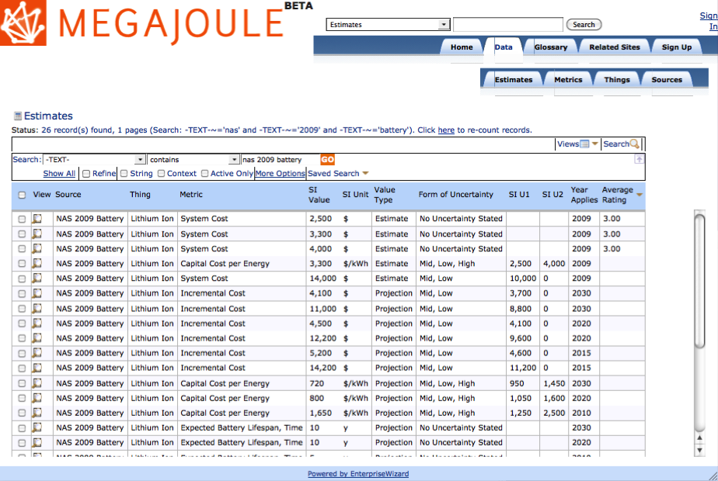
Figure 2: A Table of Estimates
The searchable table shown above is the primary way users find Estimates in MegaJoule.org
- Tables of Information: Records of each type are displayed as tables, like the Estimates table shown above in Figure 2. The table shows selected attributes by column, in this case, the Source of the information, Thing (Technology), numerical value and units, type of value, form of uncertainty, and metric, uncertainty range, date it applies, and rating. A click on a row opens the selected Estimate in a view showing details, as in Figure 3.

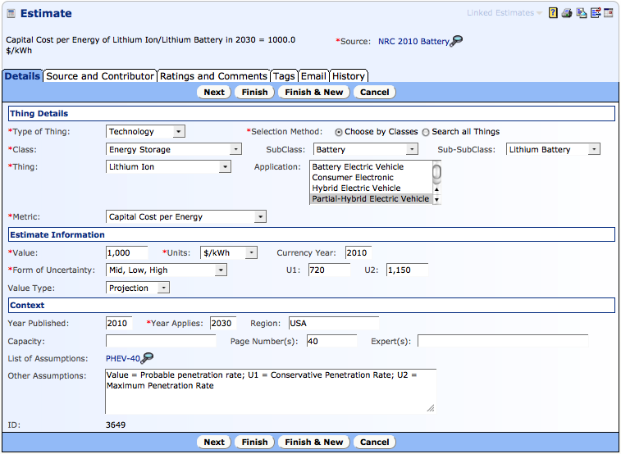
Figure 3: An Estimate in MegaJoule.org. This record is being viewed in edit mode, in which Contributors can edit the record. The other tabs allow users to view the Source information, rate and comment on the Estimate and more.
- Estimates: Each estimate is summarized by a simple statement at the top, such as “Capital Cost per Energy of Lithium Ion/Lithium Battery in 2030 =1000 $/kWh”. This summary is generated automatically from other fields in an estimate, specified by a contributor.
  - Assumptions are stated: The blue text that says “PHEV-40” is linked to a list of Estimates that are assumed in this Estimate. Contributors can also state assumptions as text in the “Other Assumptions” field.
  - Uncertainty is quantified: Estimates of the future performance of energy technologies are inevitably uncertain. Even current or past values are often uncertain, and cannot be pinned down to a single exact number — e.g., the total cost of ownership for residential solar cells depends on local labor prices, how much sun your house gets, etc. Each estimate may include a representation of its uncertainty in one of several forms, including error, standard deviation, low-mid-high values, and 10th-50th-90th percentiles.
    - In Figure 3, the Form of Uncertainty is “Mid, Low, High”, meaning that the Value, U1 and U2 fields represent mid, low and high values of this quantity respectively, without a precise explanation of what these mean, in contrast, for example, to the 10th, 50th, 90th percentiles.
- Classifying Things: Most estimates apply to either a Form of Energy, such as coal, hydrogen or electricity, or a Technology for transforming Energy (Technology for short) that transforms energy from one form into another, such as an Wind turbine that converts wind energy into electricity, an automobile that converts fuel or electricity into vehicle miles travelled, a useful energy service. A battery or other energy storage device is a Technology that transforms electricity available at one time into electricity available at a later time. Almost every Technology has some energy loss, resulting in an efficiency of less than 100%.
In MegaJoule.org, we collectively term Technologies and Forms of Energy Things. Things are categorized in a multi-level class hierarchy or taxonomy that makes it easier to find the Thing you want. See Figure 4 below for a full Thing record.
  - Applications: If a Thing is a Technology, the Application field describes what it is used for. This allows for distinctions between technologies that are functionally similar, but have different specs for their specialized use. For example, the Application in Figure 3 is “Plugin-Hybrid Electric Vehicle”, which means that the batteries in question are intended for use in a PHEV.

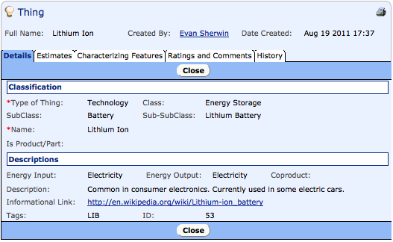
Figure 4: View of a Thing, in this case Lithium Ion battery. The tabs allow users to view estimates that apply to this Thing, characterizing features, ratings, comments on this Thing, and more.
- Full records like the Thing in Figure 4 exist for Sources, Metrics, Classes and more. Contributors can create records of most of these types. See Appendix A for a further description of the record types in MegaJoule.org and their fields.

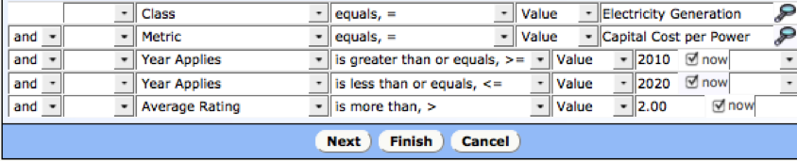
Figure 5: A Sample Query of Estimates
- Searching:
The structured nature of MegaJoule.org makes it easy to find a set of estimates of interest. For example, the search shown in Figure 5 finds all Estimates applying to the metric “Capital Cost per Power” for electricity generation technologies, between 2010 and 2020 with an average rating higher than 2. Contributors may save their favorite searches for later reuse.

Focus of Existing Content
MegaJoule.org is designed to contain information about all sorts of energy technologies and resources. For now, its focus includes depth in a few areas, notably a focus on the cost and performance of photovoltaics and advanced batteries.
Additional estimates are being added regularly. If you have requests for specific top areas for which you would like estimates, or, even better, wish to provide estimates, please contact us.

Graphing Engine
The Graphing tab provides facilities to select estimates for a given metric and technology and to generate charts of how estimates from selected sources change over time. It is implemented in Lumina's Analytica software.

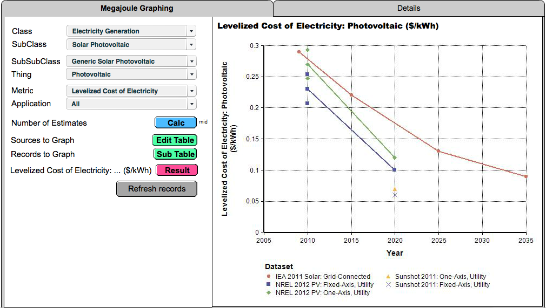
Figure 6: This is a graph generated in Megajoule’s “Graphing” tab. The filters on the left allow users to sort through the data in Megajoule to easily create customized graphs. This graph displays the projected levelized cost of electricity for utility-scale photovoltaics in several different applications. For the 2010 NREL Estimates, the graph displays low and high uncertainty values along with the mid-level values show for the other Sources.

Current Design Elements
In this section, we provide a brief outline of key design elements and features in MegaJoule.org:
Record types or object classes: As mentioned, the information in Megajoule.org is structured into a searchable database. Key record types include Things (forms of energy and technologies for transformation of energy), metrics that describe Things, estimates of the values of metrics, Sources of Estimates, contributors, and comments.
Unit conversion: Units are the bane of energy analysts, especially in the USA where analysts often use traditional systems of weights and measures, rather than the International System (SI) of units used almost universally in the rest of the World. (US analysts continue to use British Thermal Units or BTU and Quads or 10¹⁵ BTU, units no longer in use even in Britain.) MegaJoule.org supports both SI and US units. Users can enter quantities in most standard units. We are developing facilities to allow users to view estimates in the units they prefer.
Glossary: As in any discipline, specialist terms often come up in technical discussions about energy. To make energyspeak more accessible to all, we have built in a community-sourced glossary that contributors can extend, comment on, and rate.
Access control: Anyone can view any content in Megajoule.org (with the exception of other users' email addresses and contact information). Contributors who wish to enter ratings, comments, or new Estimates must register (and be verified by email). Contributions may be edited only by their author. Any contributor may add ratings and comments to any Estimate and most other types of records.
User ratings and comments: A contributor can rate the credibility of Estimates and Sources on a scale of 0 (no value) to 4 (highly credible), and add comments. These ratings are visible to all users and are currently aggregated as an average. We plan to show them also as a histogram (like product ratings on Amazon.com). We will likely expand rating and commenting to other record types as well. If a contributor uses (e.g. downloads) a set of Estimates, we may consider this as a kind of rating of the quality of those Estimates. We may weight individual ratings according to the credibility of the rater, for example based on ratings their Estimates and other contributions receive — analogous to recursive page-rank methods used by search engines.
Creating reusable lists of Estimates: Users may define a list of Estimates for their own use, and potentially for use by others. In some cases, there are causal or other relationships between quantities, so one needs Estimates that form a consistent scenario. We anticipate some users wanting to create a consistent set of Estimates for their own use. Other users will want to use such a list created by another contributor that they consider credible. Below is a picture of a list of Estimates. Contributors can create, rate, and comment on these lists just like any other record type.
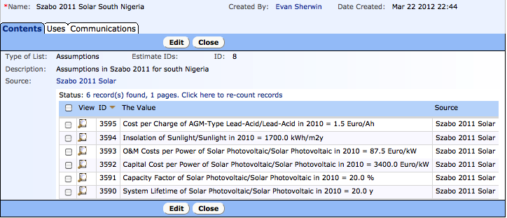
Figure 7: A List of Estimates
This is a list of assumptions implicit in Estimates of the cost of photovoltaics in Nigeria from the
Source labeled “Szabo 2011 Solar”.
Download: Users can download selected table of Estimates or Sources into standard file formats, including comma-separated tables, Microsoft Excel, and XML. Analytica users can use the MegaJoule graphing library which can conduct searches in Megajoule.org and generate tables and graphs of selected estimates for use in energy models.
Upload: If you have large numbers of Estimates, Sources, or other types of content to be added into Megajoule, it is sometimes easier to structure this into a spreadsheet or XML file to allow uploading of many records at once.

Software

Megajoule.org is implemented in EnterpriseWizard, a general-purpose commercial web-based database tool, often used for CRM, and business process automation. It provides dynamically extensible record structuring and page layout without scripting, which enables rapid progressive development. It supports a wide range of role-based access controls. It offers fast and powerful search. It uses MySQL database, and has demonstrated scalability and reliability. MegaJoule.org is currently being hosted by EnterpriseWizard. (For more, see www.EnterpriseWizard.com)
All screen shots shown are from the EnterpriseWizard user interface.
The graphing engine is implemented in Lumina’s Analytica Software.

Join the MegaJoule Community
If MegaJoule.org looks like something that you would want to use or support, there are a number of ways you can help make MegaJoule.org realize its potential.
- Browse the site, use it to find energy Estimates that you need for your energy analysis and modeling projects. You can download selected datasets into standard formats.
- Provide feedback: Provide us your comments and questions about MegaJoule.org, make suggestions for new features, and areas of content that you would like to see added.
- Add ratings and comments: Register as a contributor so that you can rate and add your comments on Estimates, Sources, and other information in Megajoule. Anyone can register easily as a contributor, provided you are willing to have your name attached to your contributions. (Contributions cannot be anonymous.)
- Contribute new Estimates and Sources: As a contributor, you can also add new Estimates, and Sources. They could include your own publications and Estimates, or others that you think should be included.
- Become a Collaborator: If you are a researcher or expert in a field related to energy technology, or otherwise have access to a large number of high-quality energy-related estimates, we would be glad to work with you to structure and import that data into MegaJoule.org. Please contact us at evan@lumina.com if you would like to become a collaborator.
- Become a Partner: We are committed to ensuring that MegaJoule.org remains a useful, transparent, accessible public resource. Although MegaJoule.org has been started as a project of Lumina Decision Systems, it is intended as a non-profit. As the “.org” indicates, MegaJoule.org does not make any money. It has received seed funding from public organizations and from Lumina. We are inviting a small number of partner organizations in government, national labs, universities, industry, and non-profits to provide guidance and funding for the development and maintenance of MegaJoule.org. If you are interested in becoming a partner, please contact us at evan@lumina.com.

Conclusion
MegaJoule.org is a unique web resource that allows energy analysts to find, share and discuss quantitative information about energy and energy technology. It can be a great deal of work to find, assess, and assemble the most credible estimates for use in energy analysis. Megajoule.org provides a way for people to collaborate and share this work. There are no certainties in the fast-moving world of energy, but our energy future is far too important to be decided uncritically. We need the best information we can get. To do this, we at MegaJoule.org place our bets on transparent, open, evidence-based discussion. The trick is, we can’t do all this without you. We welcome you to join the MegaJoule community, as a user, contributor, collaborator, or partner

SI means Systeme Internationale, or the International System of units used by scientists. US units may also be used.

