

Dear ______________

I write from Wikimedia UK on behalf of the Free Knowledge Advocacy Group EU. We are the UK-based charity that supports and promotes Wikipedia and its sister websites such as Wikimedia Commons.

Recently the European Commission undertook a public consultation on the review of EU copyright rules. This consultation is timely as we believe that current copyright rules need to be brought up to date. In particular, there are three areas which would benefit from reform:

- public domain of publicly-funded works
- use of orphan works
- freedom of panorama.

We are calling on your group of MEPs to support efforts to change the Directive to make it fit for the digital economy so that European citizens can share in the benefits of a more liberal framework.

- In terms of public domain, this would mean closing the gap that exists between Europe and the United States.
- In terms of Freedom of Panorama, this means encouraging the EU to adopt a more liberal interpretation, such as the one that exists in the UK and Germany as opposed to the tighter regime that exists in countries such as France.
- In terms of “orphan works”, this would allow their use as long as reasonable efforts are made to find the rights holder.

A simple email to stevie.benton@wikimedia.org.uk to show your support for these measures would help the open knowledge movement by helping us to make the case for the changes that we need.
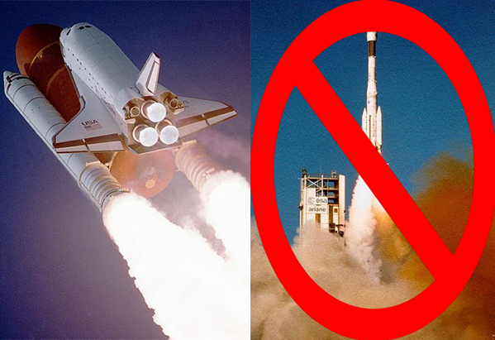We can use the public domain image of the Space Shuttle, but not the European Ariane 4 rocket

Public domain of publicly-funded works
We believe that all publicly funded works, or images of them, should belong to the public and be released into the public domain. We want to see all cultural and scientific works published by the European Union institutions, national governments and their respective agencies become freely available.
We are calling on the European Union to set the standard and become the global leader in this field. Releasing publicly funded content into the public domain will democratise it, increase competition and give start-ups a fairer chance. It will have positive effects on culture, science and the economy.
Currently the United States leads in this field as works that are funded by the taxpayer are automatically released into the public domain. An example of how this is done to great effect is NASA which releases all research, data and images created by the agency into the public domain.

Freedom of Panorama
We believe that Freedom of Panorama should be harmonised throughout the European Union.
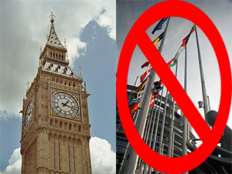UK freedom of panorama means we can use the image of Big Ben but France has no freedom of panorama so we can't use the image of the European Parliament in Strasbourg
Publishing images of publicly accessible buildings is unlawful in many EU countries, as architecture and public artworks are covered by copyright. This means that there is no freedom to use and re-use images taken in public spaces!
Freedom of Panorama allows people to freely use and share images taken in public spaces. It should apply across the European Union so that all Europeans have this freedom.
There is an excellent example that perfectly illustrates the need for change. Recently a group of photographs were taken of the European Parliament in Strasbourg for use on Wikipedia. However, the photographs of the Parliament building had to be removed from Wikimedia Commons, our freely licensed image repository, because the architect could claim copyright on the depictions of the building since France has no Freedom of Panorama regulations.

Use of orphan works
“Orphan works” are creations whose rights holder is not known. They are protected, although there is no copyright holder to ask for permission. We want to remove barriers obstructing the digitisation and use of orphan works.
We want to see orphan works digitised and used in a way that contributes to our culture, science and economy. The fastest, cheapest and most transparent way to achieve this is to remove current limitations.
We urge the European Union to revise its Directive on Orphan Works to fit the digital age in order to preserve these works that may otherwise be lost.
The current situation currently works for neither rights holders nor people wishing to make use of such works, as can be seen in this article which outlines the situation as it stands.
I hope we can count on your support and I look forward to hearing from you. Your support will help Wikipedia share and preserve open knowledge for not only ourselves but for future generations. Please do also share with your colleagues and encourage them to support change.

I am, of course, more than happy to discuss this with you further and answer any questions you may have.

Yours sincerely,

Jon Davies
Chief Executive

About us

Wikimedia UK is the UK charity that supports and promotes Wikipedia and the other Wikimedia projects. It is the UK chapter of the global Wikimedia movement and is affiliated with the Wikimedia Foundation in San Francisco.

The Free Knowledge Advocacy Group EU is an umbrella group of several European chapters of the global Wikimedia movement which has come together to work on encouraging reform to EU copyright regulations.

