TABLE OF CONTENTS:

TABLE OF CONTENTS:
INTRODUCTION
REQUIREMENTS:
KIWIX
Downloading
Installation
Use
WIKIPEDIA FOR SCHOOLS
What is a Zim file?
The offline (DVD) version
Installation
Configuration
Indexing
Using Wikipedia for Schools
Using the Search bar:
Using the Subject or Title index
ADDITIONAL TROUBLE SHOOTING
(i) Why does the software index again when opened?
(ii) My search does not return what I want?
(iii) I deleted the Kiwix Shortcut from my Desktop, How can I open Kiwix again?
DISCLAIMER

INTRODUCTION
In addition to the Online Wikipedia, it is now possible to download a copy of these Wikis and configure them to use offline, which means the content is still accessible even without internet connection! The Wikipedia for Schools includes content that has relevance to students both in High Schools and Colleges carefully handpicked and edited by SOS volunteers. Adult and irrelevant content is edited by deletion.

Anyone can take advantage of this fact to carry out an outreach project to schools with the offline (DVD) version of Wikipedia for Schools, and empower the students with a huge knowledge base free of cost. This guide will walk you through all the requirements and the process of installation, configuration and use of Wikipedia for Schools DVD version.

PS: This guide focuses on and makes references to the DVD version of Wikipedia for Schools Suite, compiled by Wikimedia Kenya.

CONTENTS
This DVD suite contains:
- Kiwix Directory-this contains the software that reads the Wikipedia Content
- The Wikipedia for Schools.zim--this is the file that is the content. It is compressed in a .zim format
- The Wikipedia for Schools-User Manual---this is what you are reading now! It is the guide to use and installation of the Wikipedia for Schools. It also has support and troubleshooting information

REQUIREMENTS:
Software:
- Kiwix v0.9 alpha 7 (provided in the DVD suite)
- Wikipedia for Schools 2008/2009 Zim file (Included in the suite)
- A computer with Linux or Windows Operating system
- An optimum of 10GB of space in the Hard Disk

KIWIX
Kiwix is a small free license software that is used to view web pages offline by reading a special compressed package of the website known as a ZIM file (*.zim)

Downloading
The installation package for this software can be downloaded from the Kiwix.org website.
Download Links
- Kiwix for Windows 32 bit OS
- Kiwix for Linux deb i386
- Kiwix for Linux deb amd64

Installation
The DVD suite comes with a Kiwix installation directory, so you do not need to download it.
Installation is very simple:
For Windows OS
- Insert the DVD and browse its content. Copy the entire folder named KIWIX
- Go to C:\Program Files in your computer. This is reached by opening the start menu> My Computer> Local Disk(C)>Program files
- Paste the Kiwix folder there
- Open the folder that you pasted (C:\Program Files\Kiwix)
- Scroll down to a file named Kiwix (with a black image of a bird head) and right click on the file. On the menu that appears, point the cursor on “send to” and select –Desktop(create shortcut)

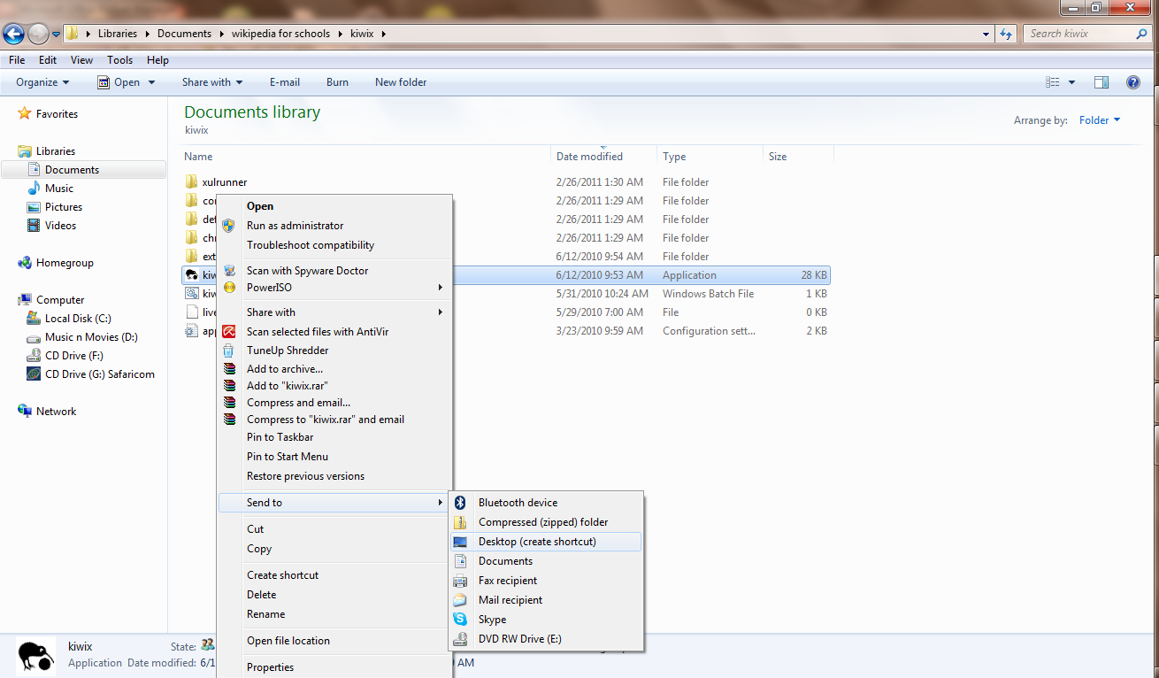
You have successfully installed Kiwix and you can run it by double clicking on the Kiwix Shortcut on the desktop

Use
When you open Kiwix, you will see the following screen. Now the next step is to open the Wikipedia for Schools using Kiwix.
Please read the next part below under the use of Wikipedia for schools to know how to open the zim file.
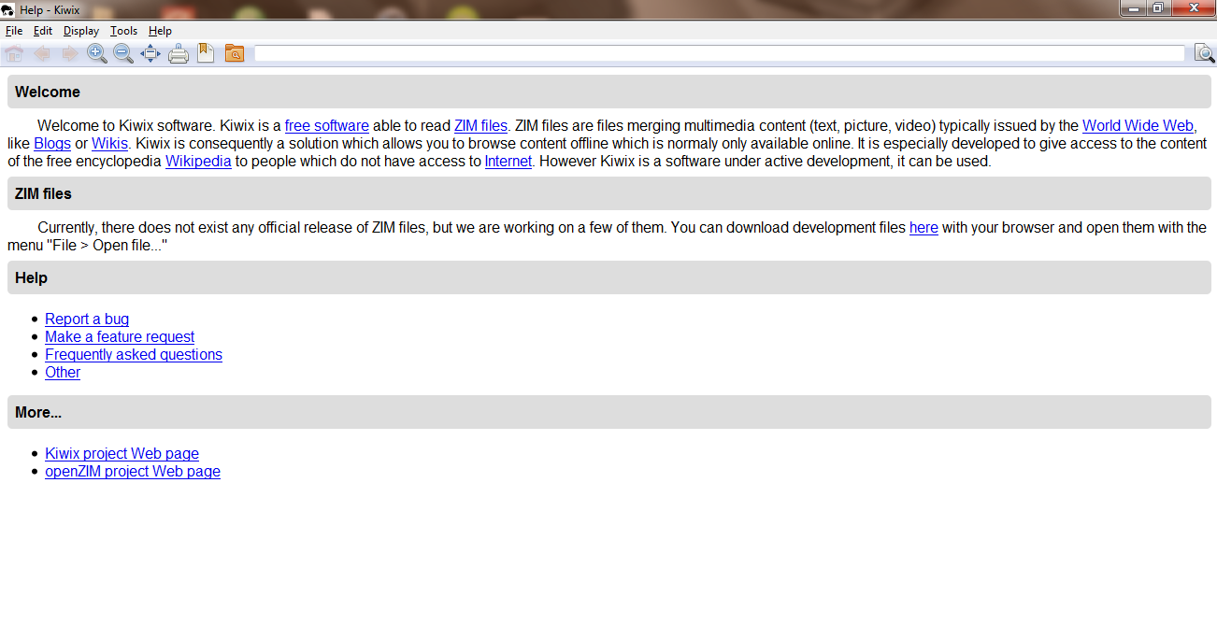

WIKIPEDIA FOR SCHOOLS
Wikipedia for Schools is a wiki project that contains open source content covering most of the subjects that are taught in schools. This version comes in a zim format, packaged in a DVD

What is a Zim file?
A zim file is a highly compressed package that contains the full content of a website that can be browsed offline, plus some other Meta data to enable ease of navigation

The offline (DVD) version
The zim version of Wikimedia for schools can be downloaded online here. Wikimedia Kenya has compiled a DVD that contains the zim file ready, so it can be used without requiring any internet connection. This is what has been referred to as the offline version of Wikipedia for Schools.

Installation
- Insert the DVD and open it to view the files.
- Copy the file named Wikipedia for Schools.zim to whichever location you like. I recommend that you copy it and paste it in the “Documents” folder. To do this, go to the start menu of the computer and click “My Documents”. Paste the file there

Configuration
Up to now, the installation is almost complete. Just a few things to note:
Please paste the zim file in a location where no one can tamper with it, and do not move this file unless it is necessary.
Now go to the desktop to open Kiwix as explained in section 3 (b) above.

Indexing
When Wikipedia for Schools zim file is opened for the first time, it is not possible to type keywords in the search bar for easy access. In order to achieve this, the zim files needs to undergo indexing. This process enables Kiwix to create an index of all the words contained so that it can be easy for the user to access any article by searching the keywords.
The indexing process starts automatically when the zim is opened the first time. Allow or accept the indexing option when prompted for the first time. (You can then use the Wikipedia for Schools on subsequent times without the need for indexing)
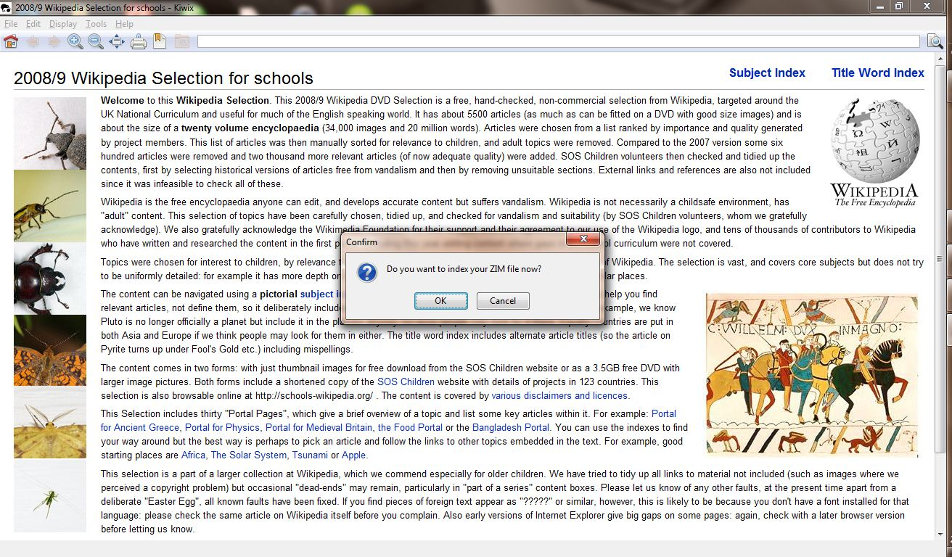
Let the indexing process run to 100%

Using Wikipedia for Schools
Your computer is now fully configured to use the offline version of Wikipedia for Schools. Let us now walk you through some simple navigation guides on using Wikimedia for schools.
There are two ways you can find the articles you need to study:

Using the Search bar:
Click on the search bar and type any keyword for the topic or subject you want.
On the left sidebar list of related hyperlinks will appear. Select the one that suits you or what you are interested in.

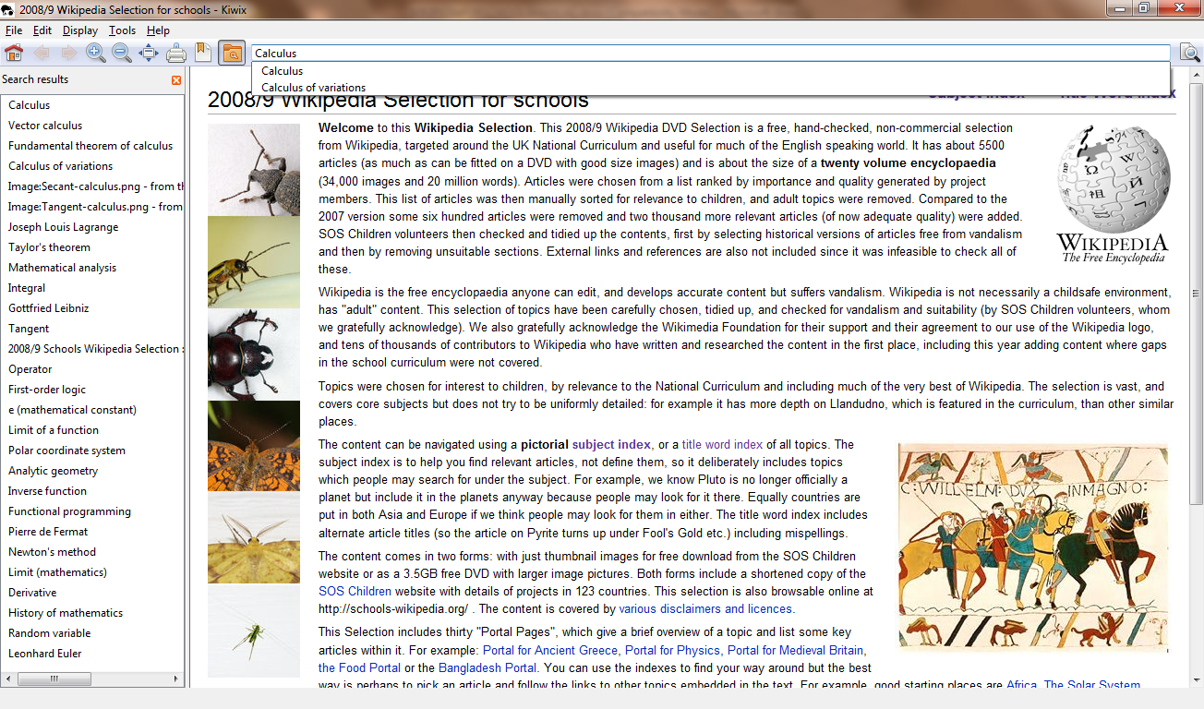

NB: Hyperlinked text (appearing in blue) will also take you to that article.

Using the Subject or Title index
Above the Kiwix, are the title boxes of the Subject and index option
The subject index lists all the subject matter covered: like Geography,Physics,Biology and so forth)
Select the subject matter you wish to read on like Mathematics

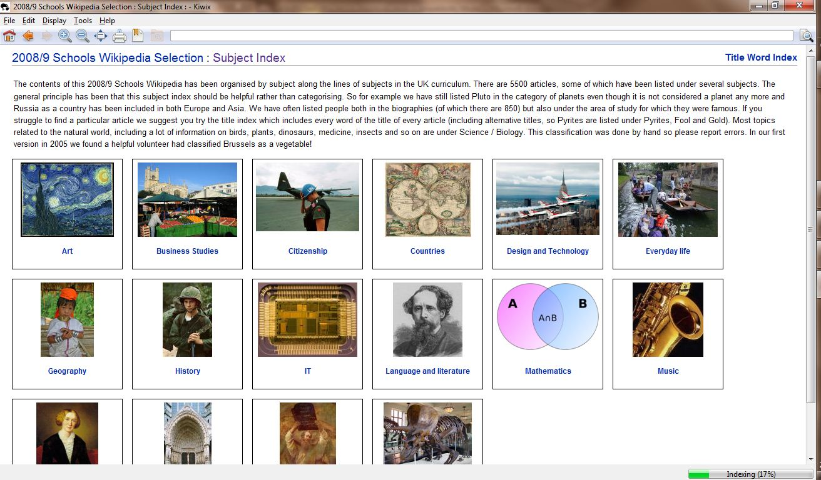Select from the list of topics covered in Mathematics that you want to read on e.g.

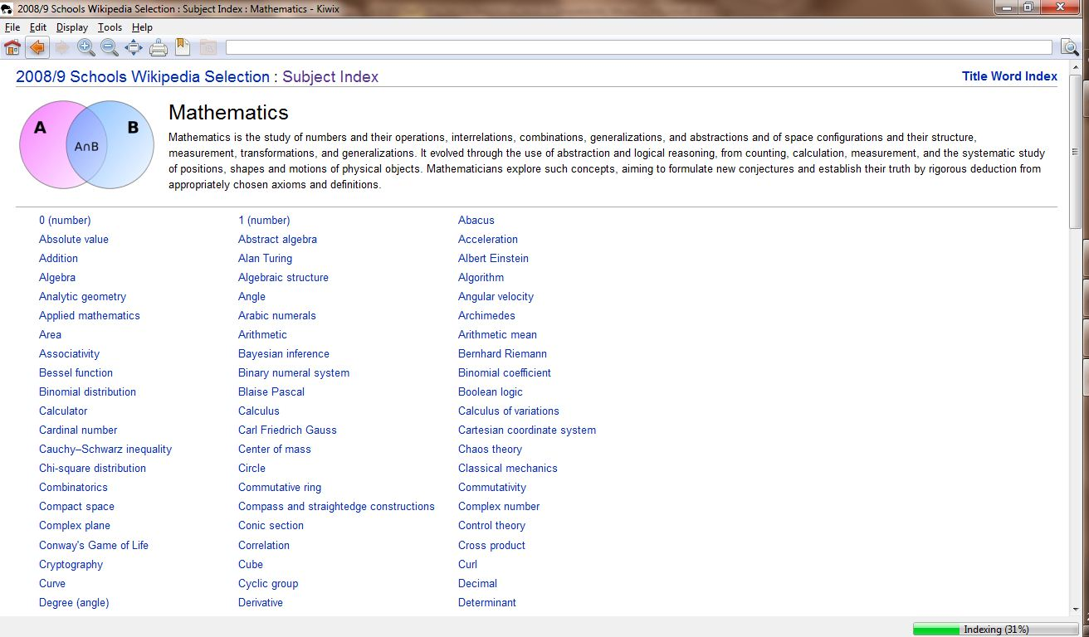
Calculus and off u go...
The Title Word Index lists all the articles in alphabetical order. Simply click on the Title Word Index tab above the Kiwix and then select the alphabetical letter representing the article you wish to read or find. All the articles are listed. Select that which you want.

ADDITIONAL TROUBLE SHOOTING

(i) Why does the software index again when opened?
The zim file index that is created during the indexing process depends on the location of the .zim file.
If you change the location of the zim file slightly, the indexing process has to be done again for the search functionality to work. That is why it is advisable that you save the zim file in a location where no one can tamper with it unnecessarily.However, you can still use the Title and Subject indices even without indexing or while indexing is in progress.

(ii) My search does not return what I want?
Well, probably you misspelled your search criteria or what you are looking for has a different name. Try a synonym or related word (it happened to me when I was searching for Menstruation, it did not return anything but when I tried Female reproductive system, there I got it!!)

(iii) I deleted the Kiwix Shortcut from my Desktop, How can I open Kiwix again?
Never worry! The desktop shortcut is not the only way to open Kiwix. You can open Kiwix any time by opening the installation directory i.e. C:\Program Files\kiwi by opening the Start menu>My Computer> Local Drive C > Program Files > Kiwix. In this folder, right click to open the application file named Kiwix.
You can then restore the Desktop shortcut as previous.

(iv)The installation of Kiwix Says, ‘Not enough memory’’
Well maybe you double clicked on the Kiwix.exe in the directory. It is attempting to install. Since the Kiwix version used here does not necessarily need to be installed, just refer to the Kiwix installation section at the beginning. However should you want to install, cancel the installation and then create a directory/folder in a drive of your choice that has enough capacity Start the installation again by double clicking on the kiwix.exe and then browse to the folder you created….finish off the installation..

DISCLAIMER
  - This is not the official manual of the Wikipedia for schools, but one prepared by Wikimedia Kenya for the schools in which the Wikipedia for Schools Project is taking place. It is not a guarantee that the information given herein is 100% accurate.
  - The Wikipedia for Schools is not a substitute for the school curricula; should you find anything contradicting the teachers or curricula textbooks, please do consult your teacher.
  - While great care has been observed in selecting relevant content to school going students, under no circumstances will the Wikimedia foundation and Wikimedia Kenya be liable to any harm or damage that may arise for usage of this content.
  - The Wikimedia Foundation and Wikipedia for Schools Selection disclaimers apply too.

Return to Top

